**Introduction**

UPDuino is an ultra low cost FPGA development and prototyping board. The OV7670 Camera Module is an ultra low cost VGA camera module traditionally used for maker projects. The UPDuino OV7670 Camera Module Adapter Board connects a OV7670 camera module to a UPDuino v2.0 board. This user guide describes the hardware and software necessary to connect the OV7670 Camera module and an Arduino to a UPDuino board and stream image data from the Ultraplus FPGA frame buffer to a computer via UART. The image data can then be copied into a file and be viewed as a bitmap.

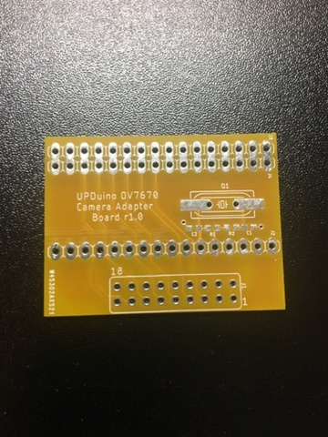

**Required Hardware**

* UPDuino v2.0
* OV7670 Camera Module
* UPDuino OV7670 Camera Adapter Board r1.0
* Any Atmel Atmega328 Board (We will use the Arduino Nano Board through this user guide)
* Computer (We will use a Windows PC for this user guide)
* 2x9 Female Header
* QTY 1 – 1x16 Male Header
* QTY 1 – 1x18 Male Header
* QTY 2 – 1x16 Female Headers (if you can only find 1x15, this is also fine)
* QTY 1 – 1x2 Right Angle Male Header
* QTY 1 – 1x4 Right Angle Male Header

**Required Software**

* Lattice Diamond Programmer
  + <http://www.latticesemi.com/en/Products/DesignSoftwareAndIP/ProgrammingAndConfigurationSw/Programmer>
* Lattice iCECube Software
  + <http://www.latticesemi.com/Products/DesignSoftwareAndIP/FPGAandLDS/iCEcube2>
* Arduino IDE
  + <https://www.arduino.cc/en/Main/Software>
* HxD Hex Editor
  + <https://mh-nexus.de/en/downloads.php?product=HxD>

**Hardware Setup**

1. Solder one 2x9 female header to the top side to the UPDuino OV7670 Camera Adapter Board

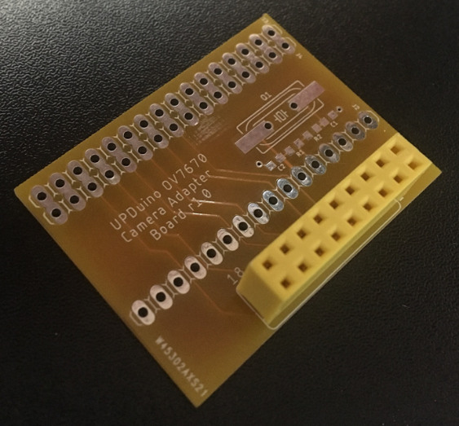

1. Solder two 1x16 female headers to the bottom side of the UPDuino OV7670 Camera Adapter Board

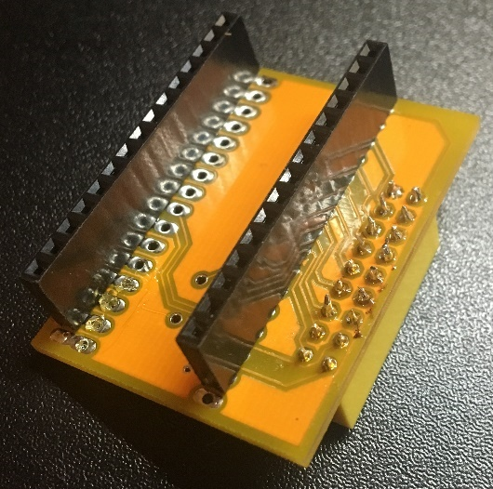

1. Solder an additional 1x4 right angle male .1” header to the top side of the camera adapter board. This will be to connect the SPI interface between the Arduino and the UPDuino v2.0.

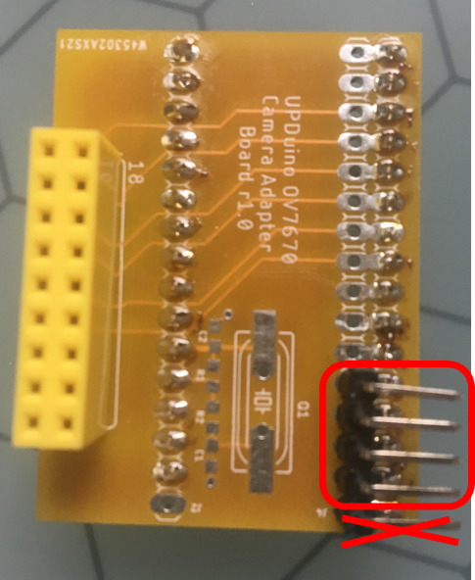

1. Solder 1x16 and 1x18 male headers to the bottom side of the UPDuino v2.0 board. Solder a right angle 1x2 male header to the 5V and GND header of the UPDuino v2.0 board.

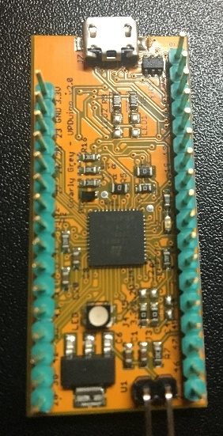

1. Connect the OV7670 Camera Module and UPDuino v2.0 to the Camera Adapter Board.

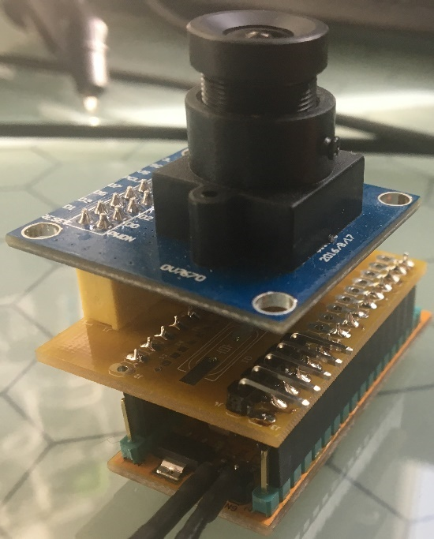

1. Connect the Arduino Nano and UPDuino v2.0 SPI pins using EZ-Hook jumper wires. Connect 5V and GND pins between Arduino Nano and UPDuino v2.0 using EZ-Hook jumper wires.

|  |  |  |
| --- | --- | --- |
| **SPI Pin** | **Arduino Nano Pin** | **UPDuino v2.0 Pin** |
| SSN | 9 | 46 |
| SCK | 13 | 47 |
| MOSI | 11 | 48 |
| MISO | 12 | 45 |

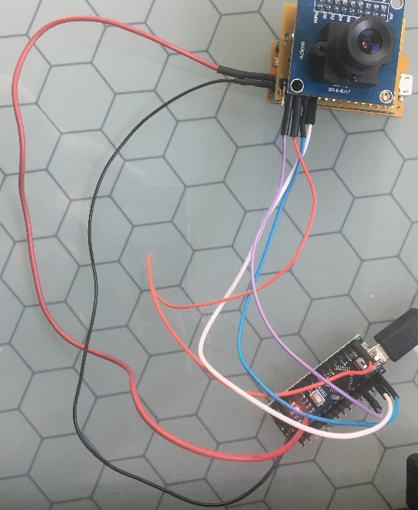

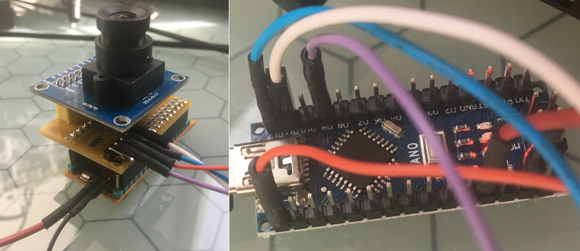

**FPGA Bitstream/Firmware Programming:**

1. Open Lattice Diamond Programmer. Allow the software to complete the scan; the software will say “Generic Device” since the UPDuino v2.0 board defaults to SPI flash programming and boot.
2. Then configure the software for the following settings. Go to “Edit 🡪 Device Properties” to access the Device Properties window.

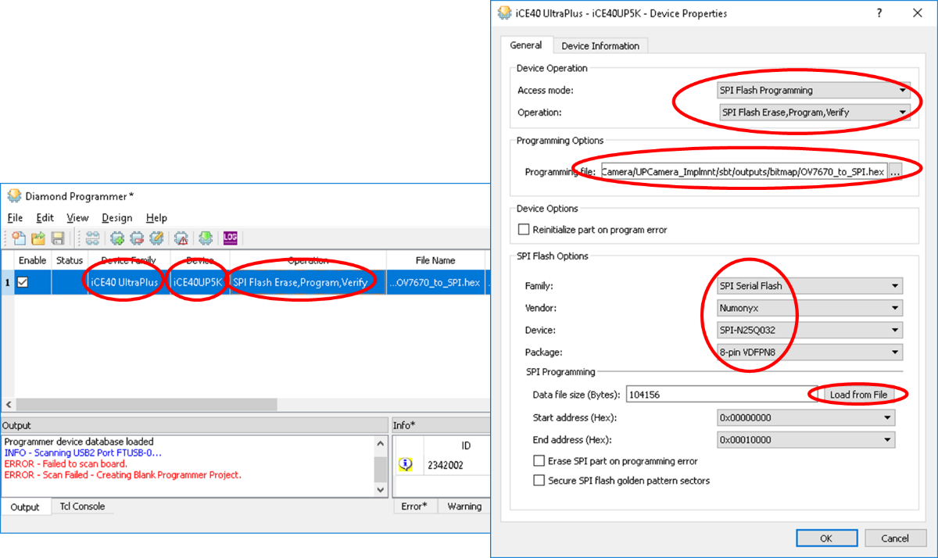

1. Click ‘Program’ under the “Design” tab. The flash should program successfully and the green CDONE D7 LED should light up on the UPDuino v2.0 board (if no bitstream/firmware was already loaded).

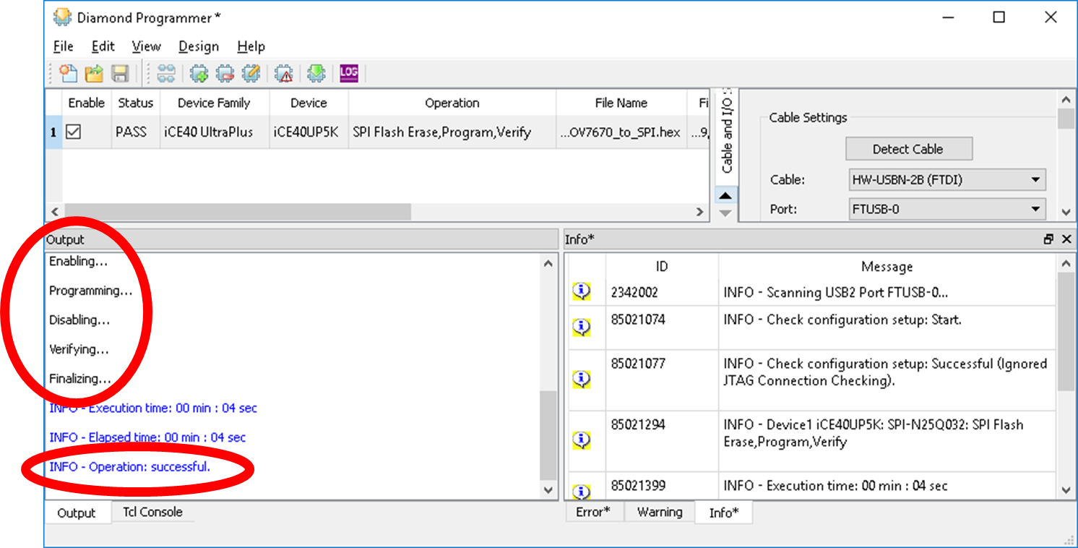

1. Open Arduino. Load firmware. Open terminal.
2. Copy data streamed to terminal window to file using HxD. Change the file extension to *.bmp
3. Open the bitmap file to view the image.

**Arduino Firmware Programming and Bitmap Extraction:**

1. Install Arduino IDE. Install HxD Hex Editor.
2. Double click on the SPI2UART.ino file to open Arduino IDE and the project.

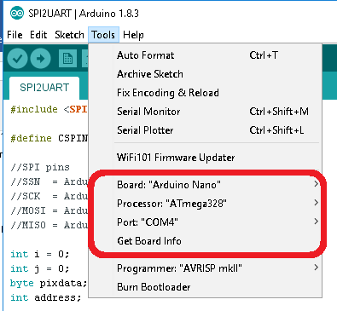

1. Open the serial monitor window. Set the baud rate to 115200 and “No line ending”

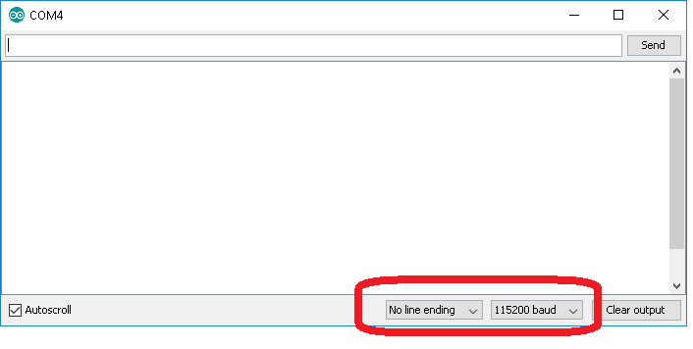

1. In the Arduino IDE click “Sketch 🡪 Upload” to compile and upload the design to the Arduino board. Once uploaded the program will automatically run and data should start populating in the terminal window. This is the bitmap data from the image captured from the camera.
2. Go to the terminal window. Press CTRL-A to select all of the hex data in the terminal window. Press CTRL-C to copy the hex data.

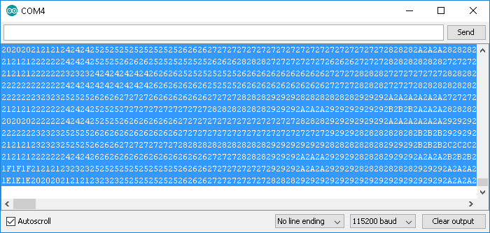

1. Open HxD Hex Editor. On a new file press “CTRL-V” to paste the hex data into the file. Click “OK” if there is a message regarding a change in the file size.
2. Save the file by clicking “File 🡪 Save.” Name the file with the extension *.bmp.
3. Navigate to the *.bmp file that was just saved and open it. You should see the image from the OV7670 camera.

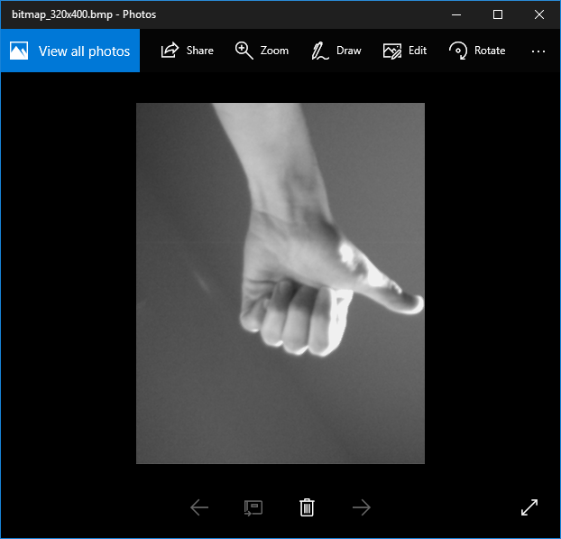

**FPGA Design:**

